**ASW Login with Username**

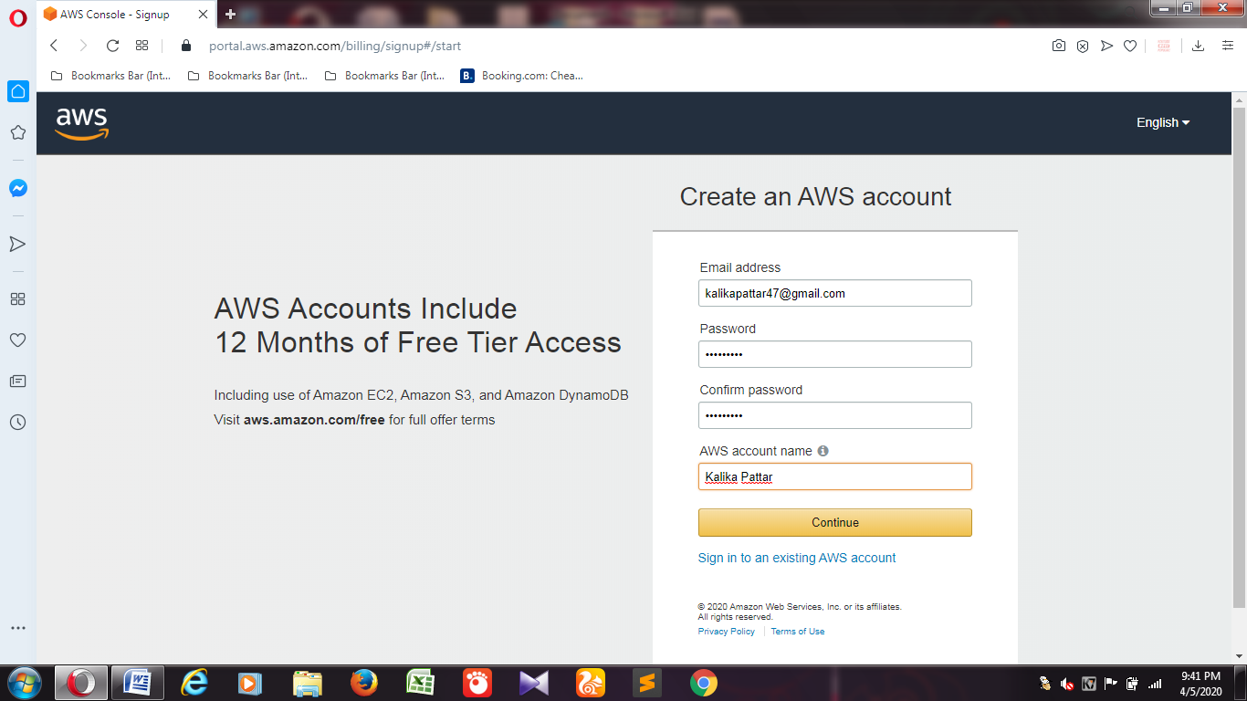

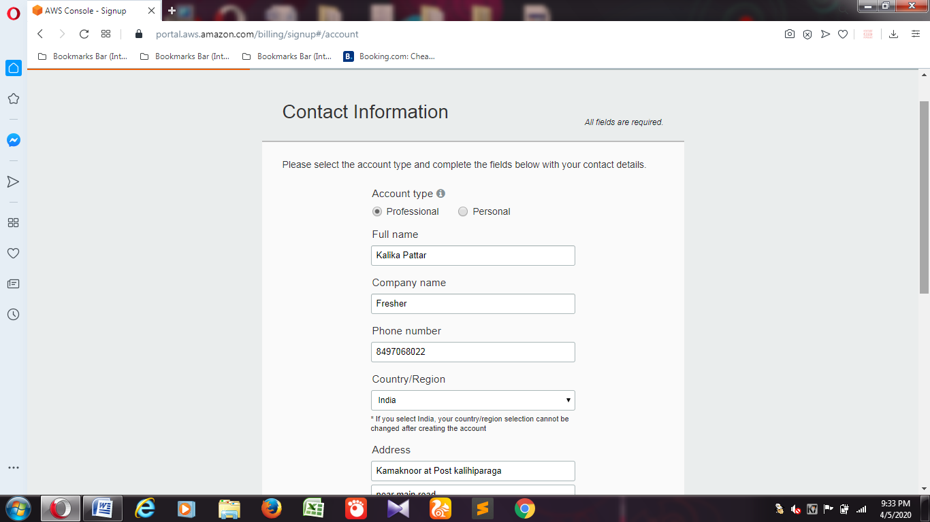

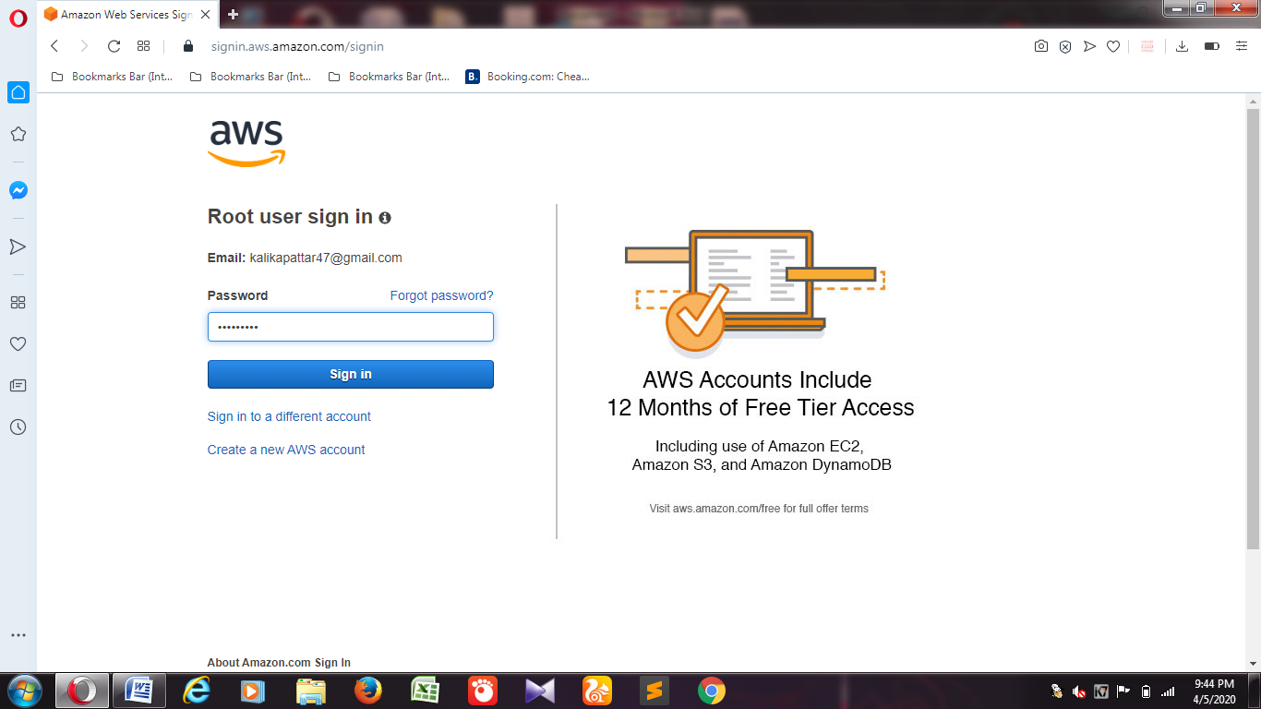

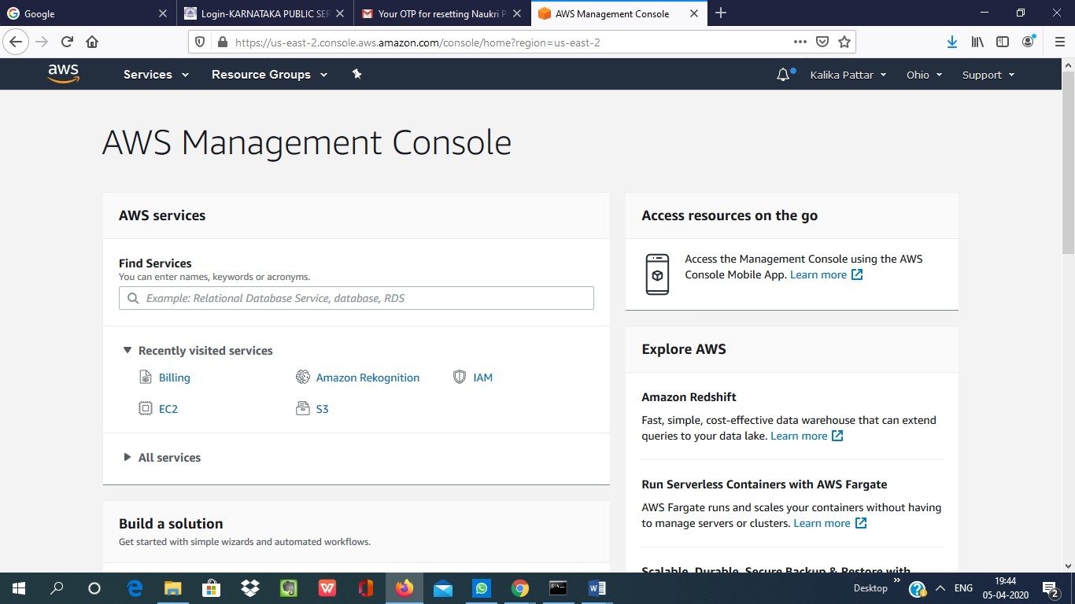

**EC2 Dashboard**

**1.Choosing an AMI**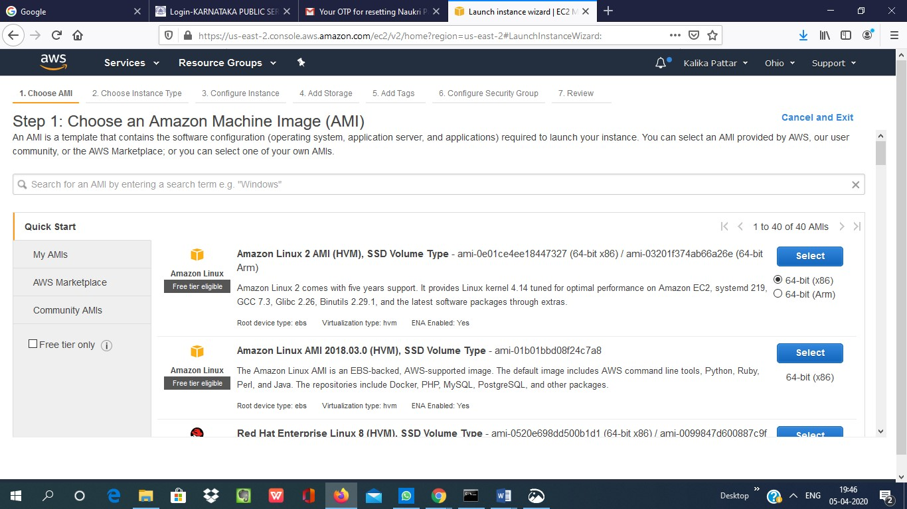

**2.Choosing an Instance Type**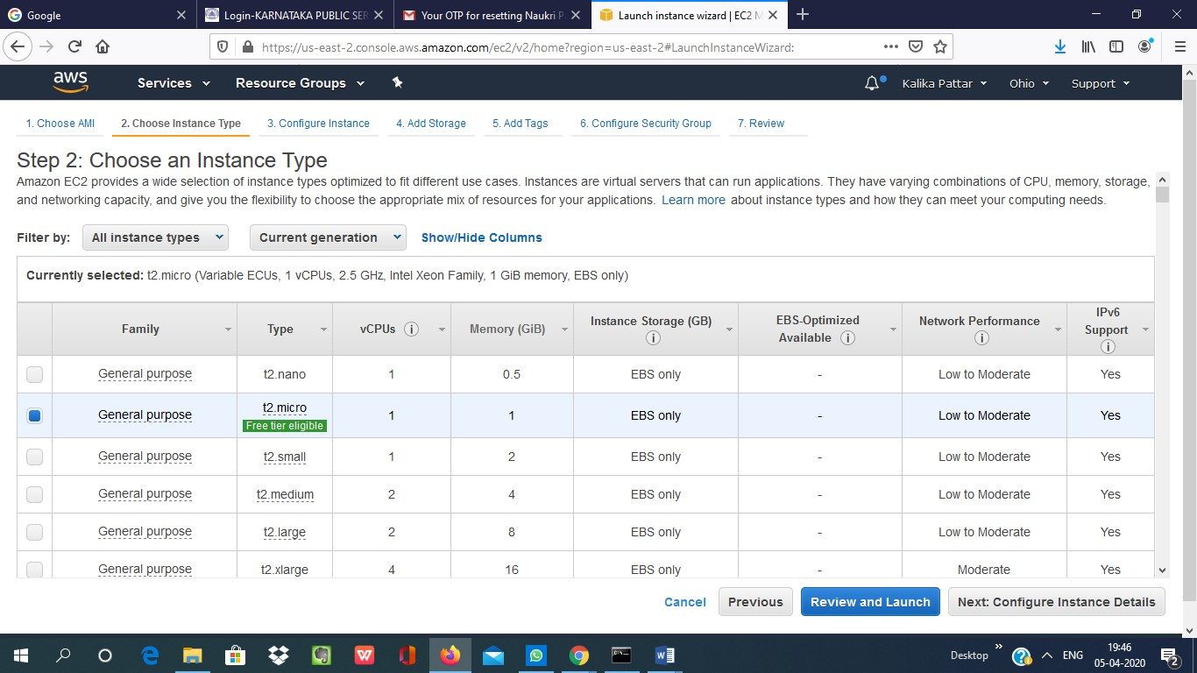

**3.Adding Storage**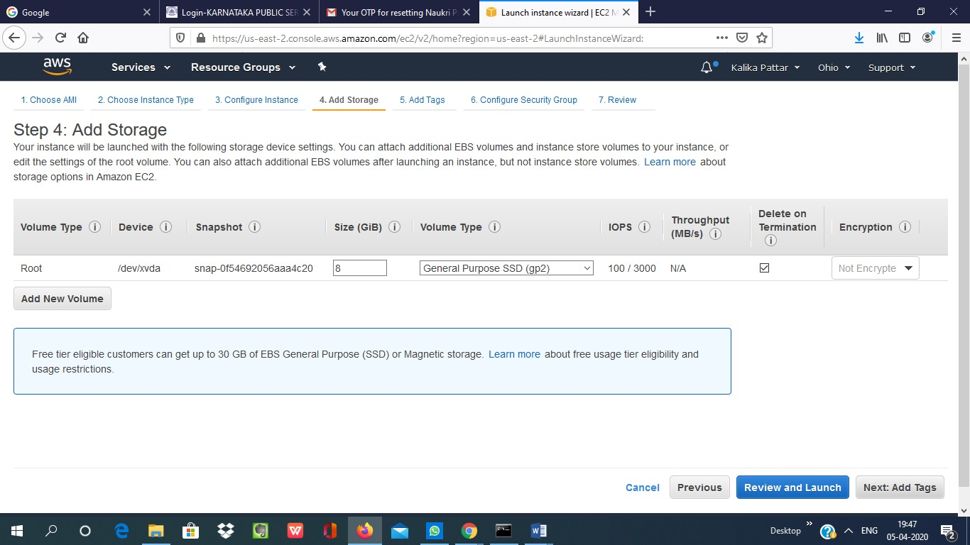

**4. Configuring Security Group**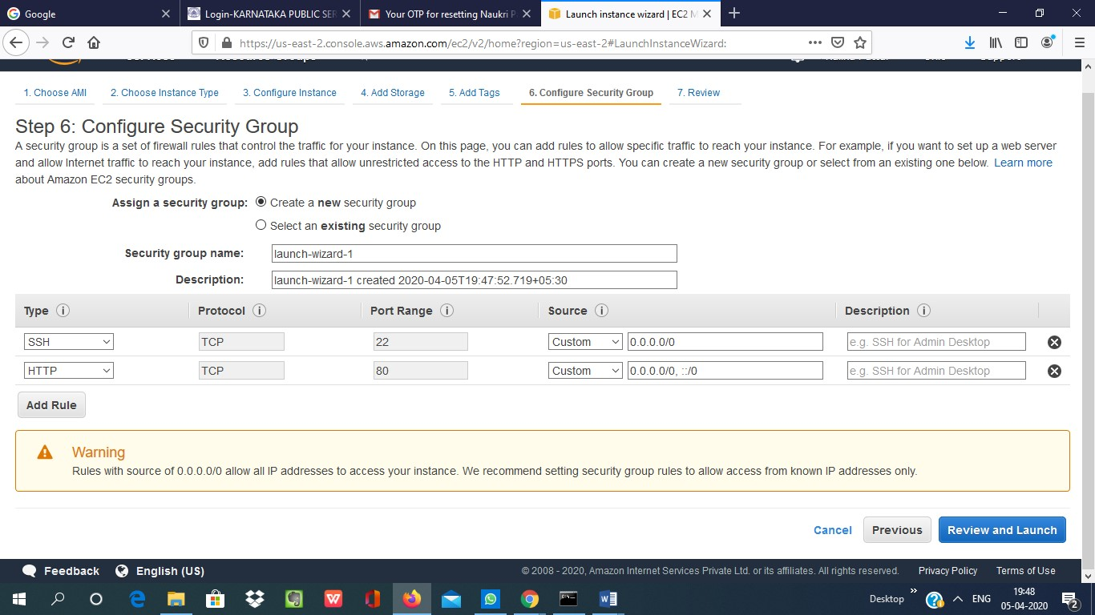

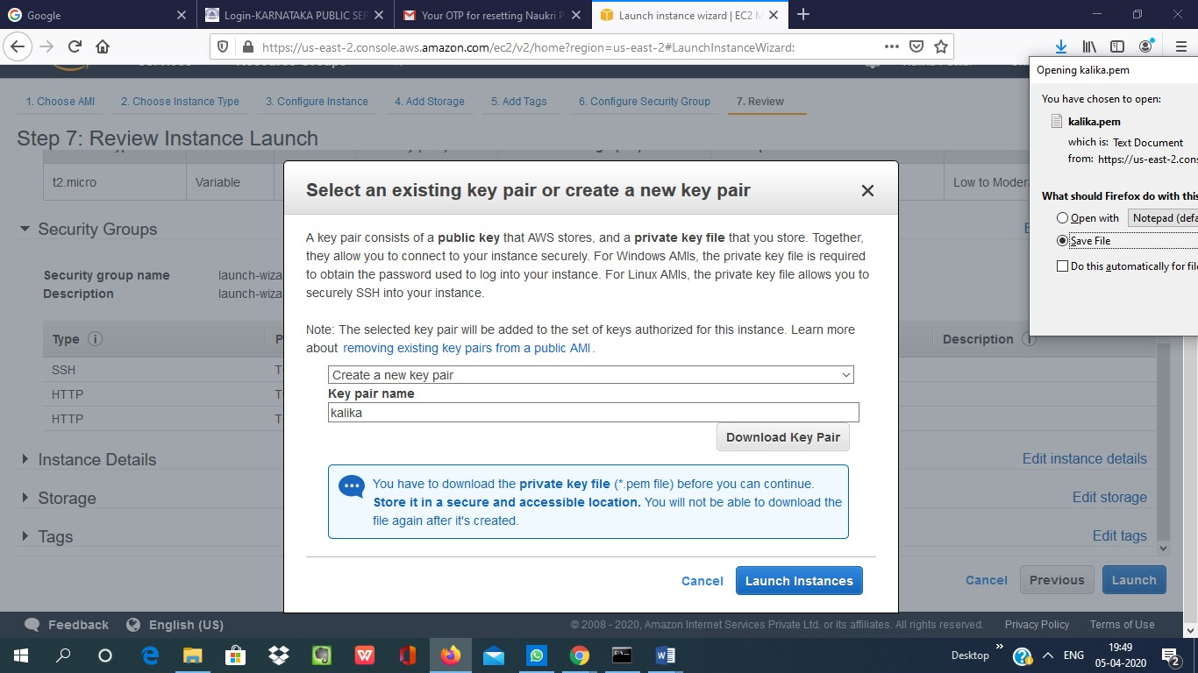**5.Key Paid Download**

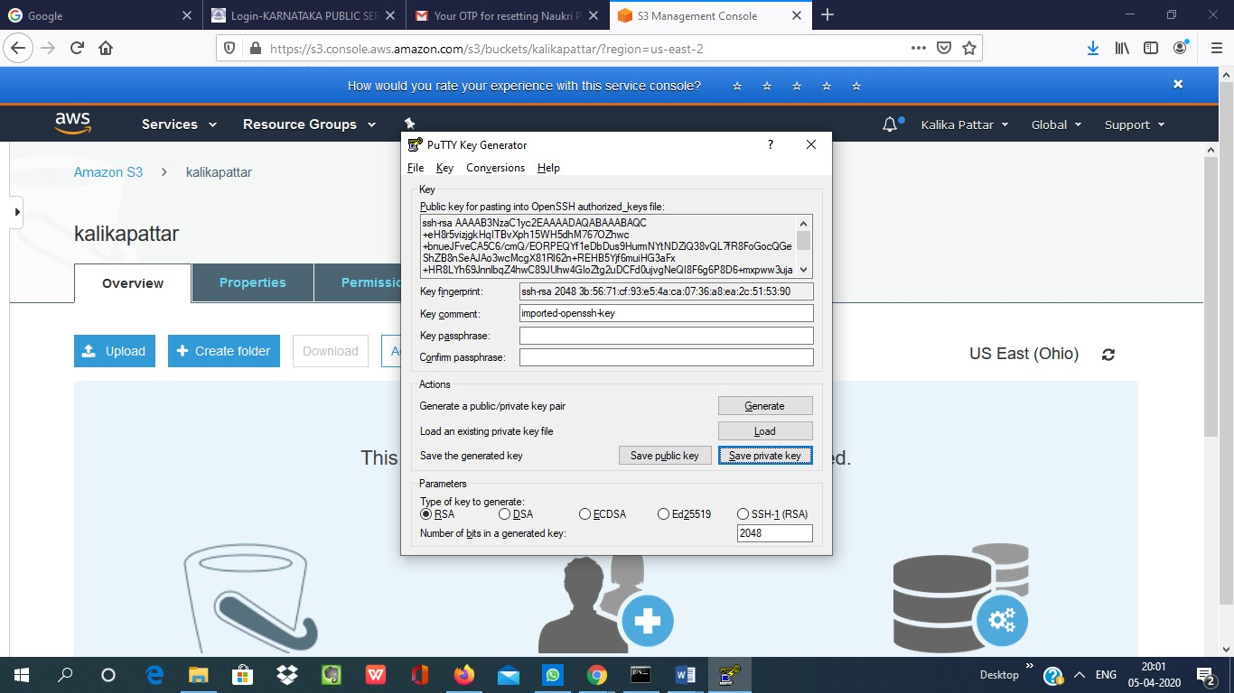**6.PuTTYgen conversion from pem to ppk**

**7. Logged in EC2 black screen**

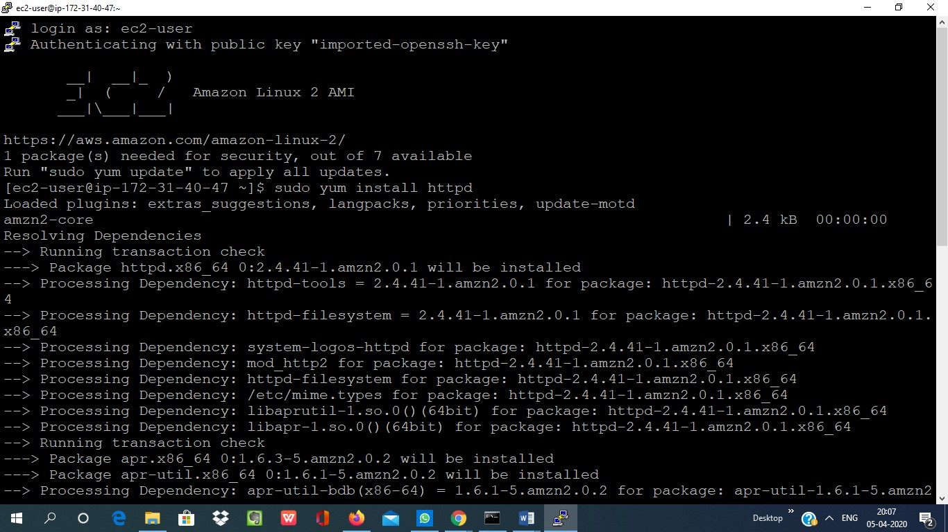

**3. S3 Dashboard**

**1. Creating a bucket**

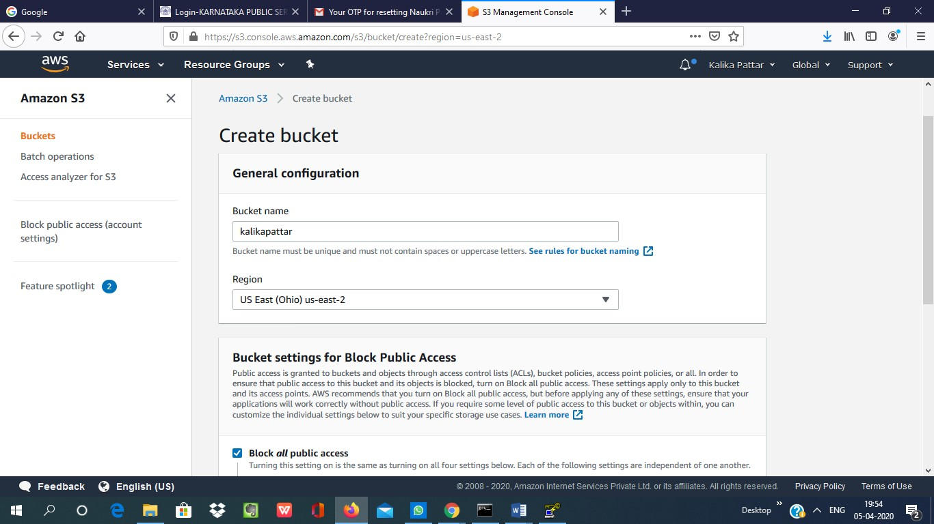

**2. Uploading an Object**

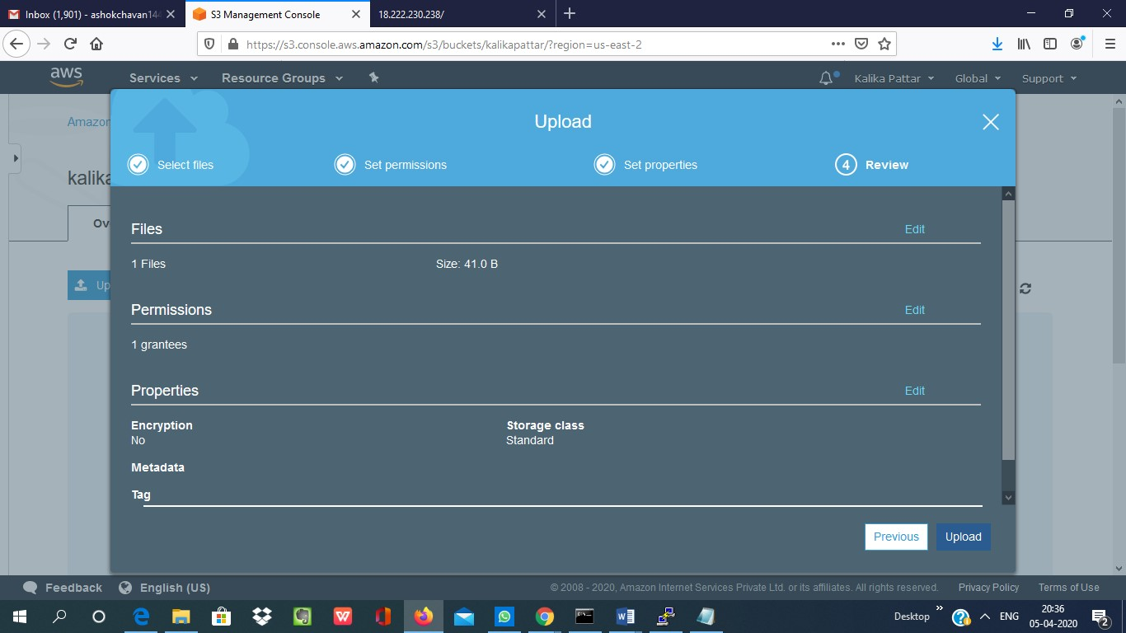

**3. Enabling Static Website**

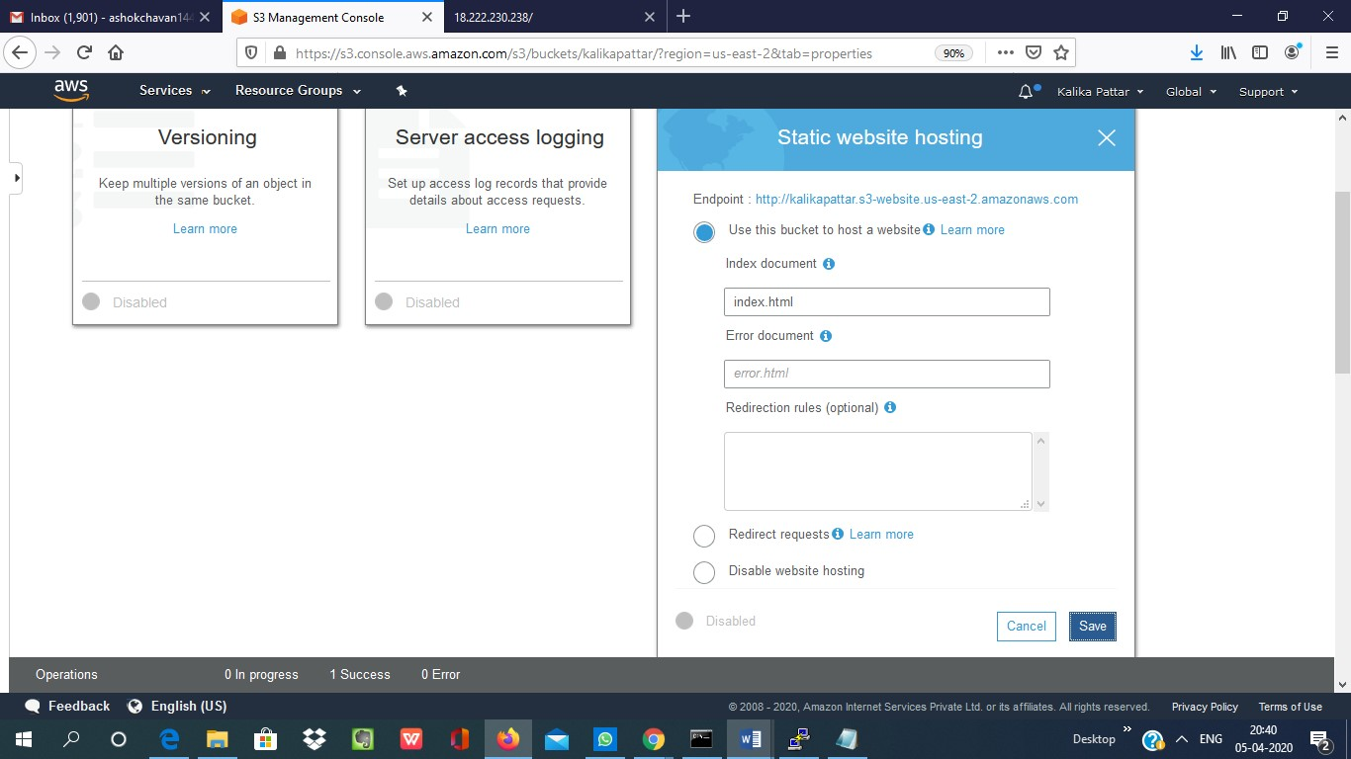

**4.Making the Object Public**

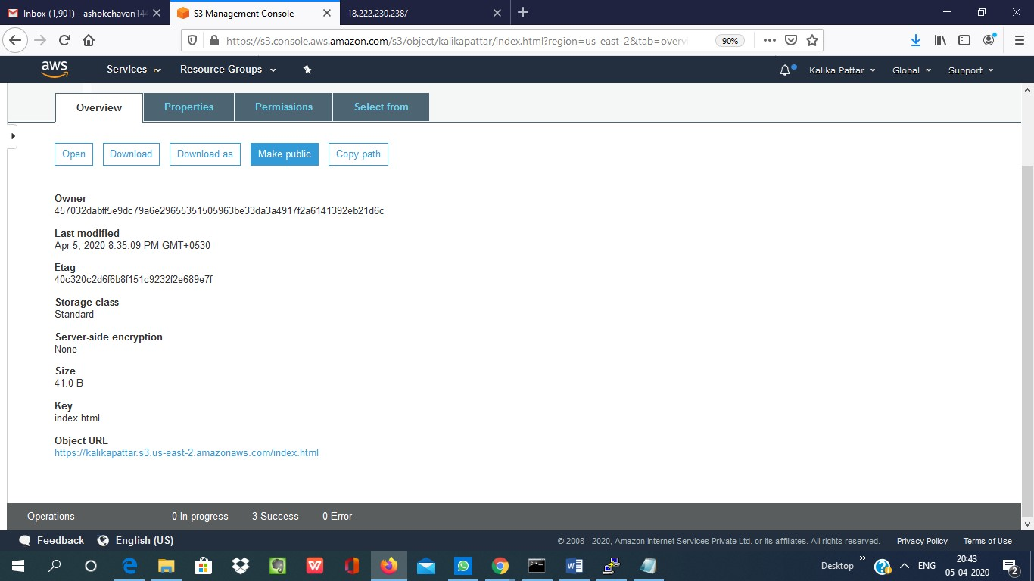

**5 .Checking the S3 link on the browser**

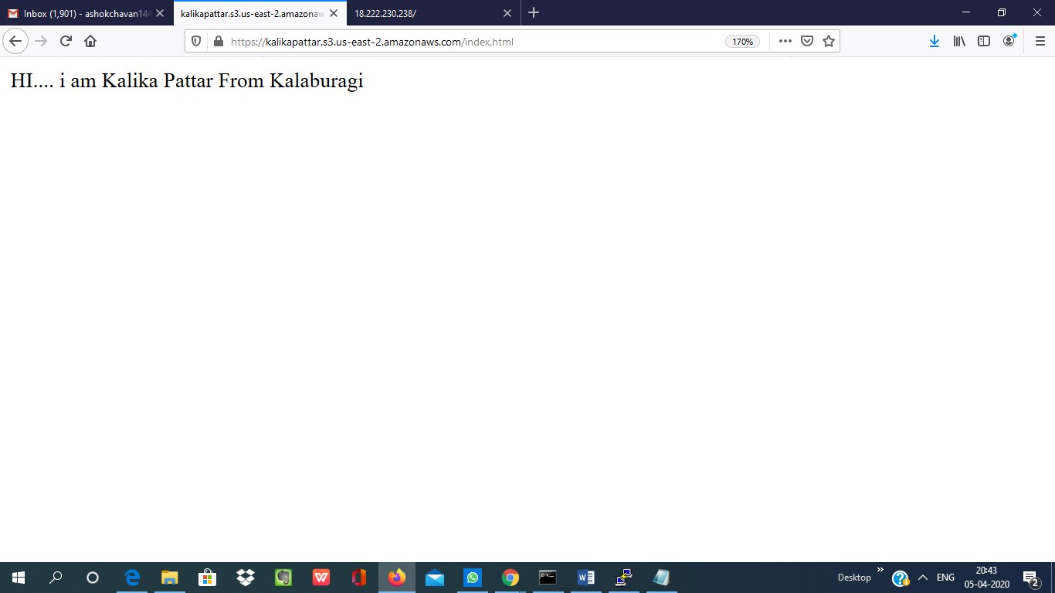

**Amazon Rekognition**

1. [**Facial analysis**](https://us-east-2.console.aws.amazon.com/rekognition/home?region=us-east-2#/face-detection)

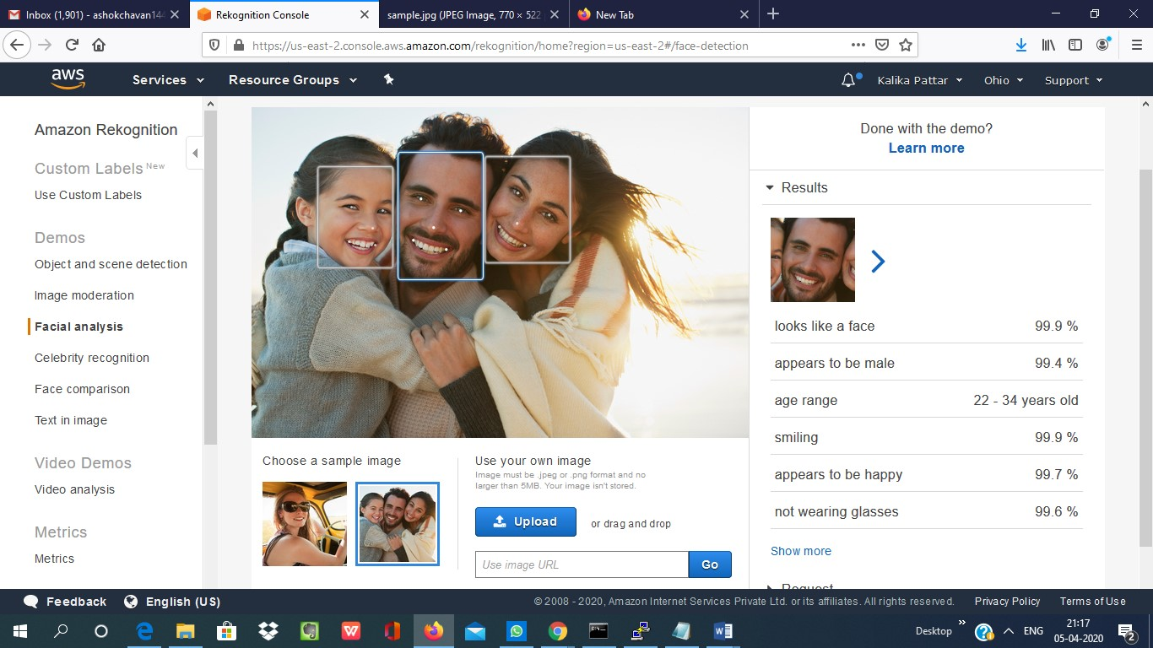

**2.[Face comparison](https://us-east-2.console.aws.amazon.com/rekognition/home?region=us-east-2" \l "/face-comparison)**

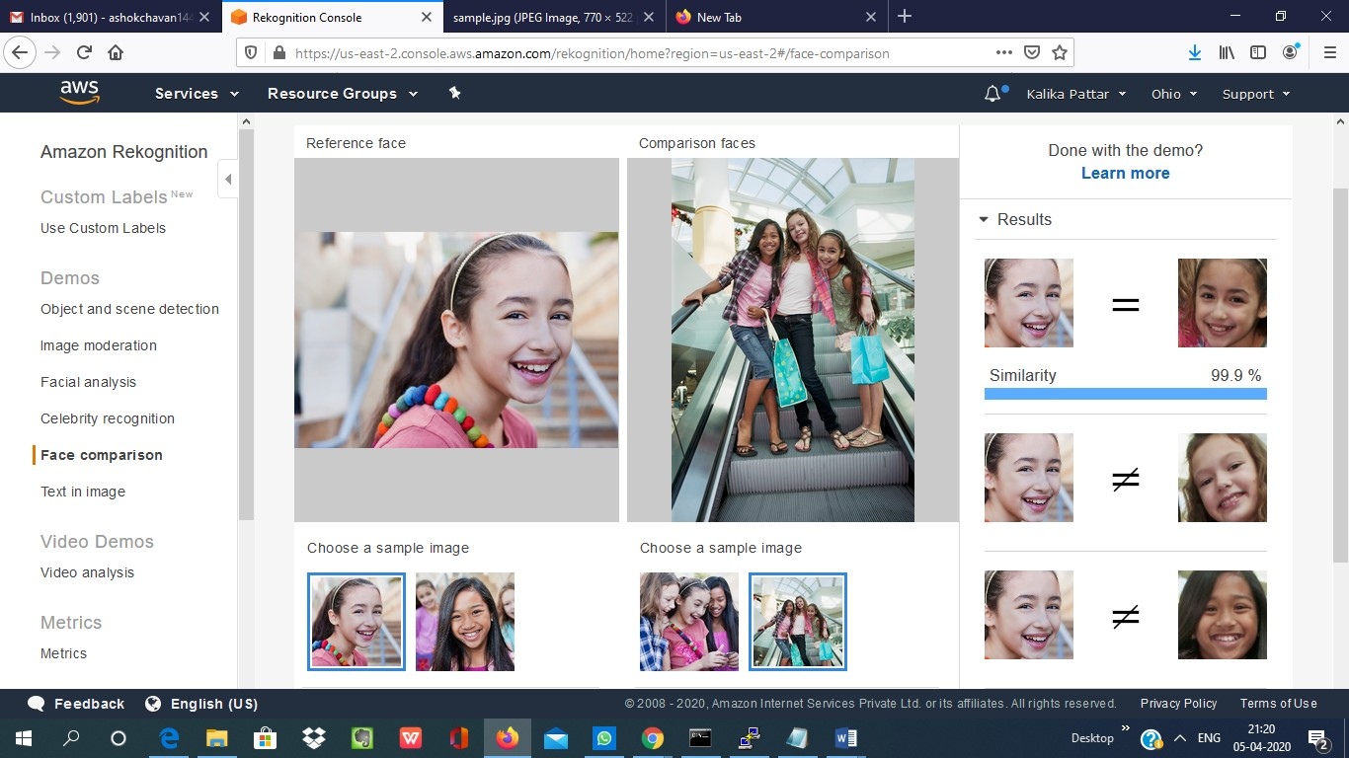

1. [**Celebrity recognition**](https://us-east-2.console.aws.amazon.com/rekognition/home?region=us-east-2#/celebrity-detection)

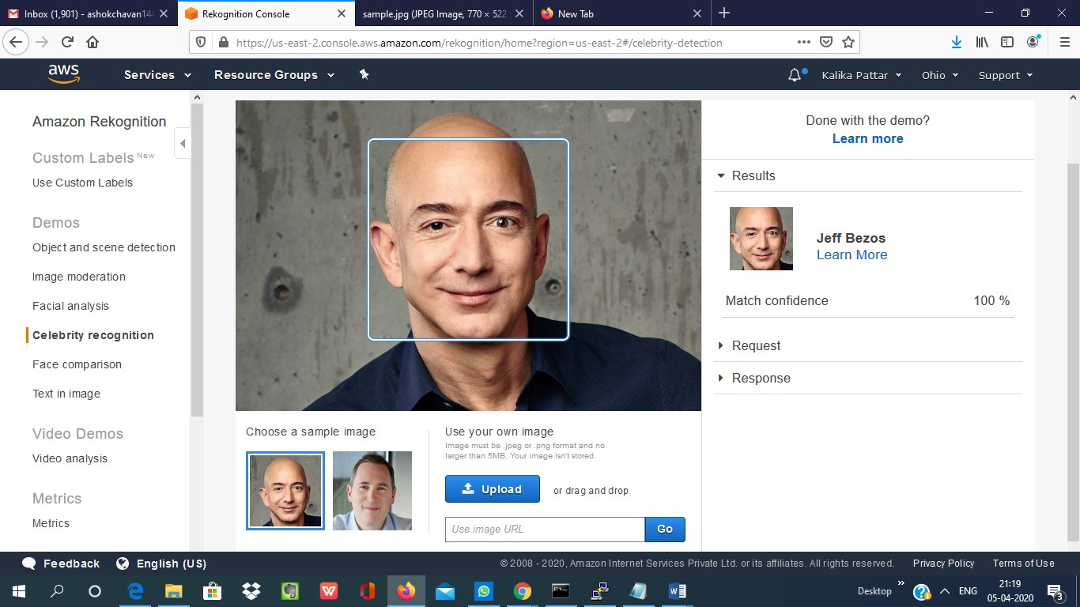

1. [**Text in image**](https://us-east-2.console.aws.amazon.com/rekognition/home?region=us-east-2#/text-detection)

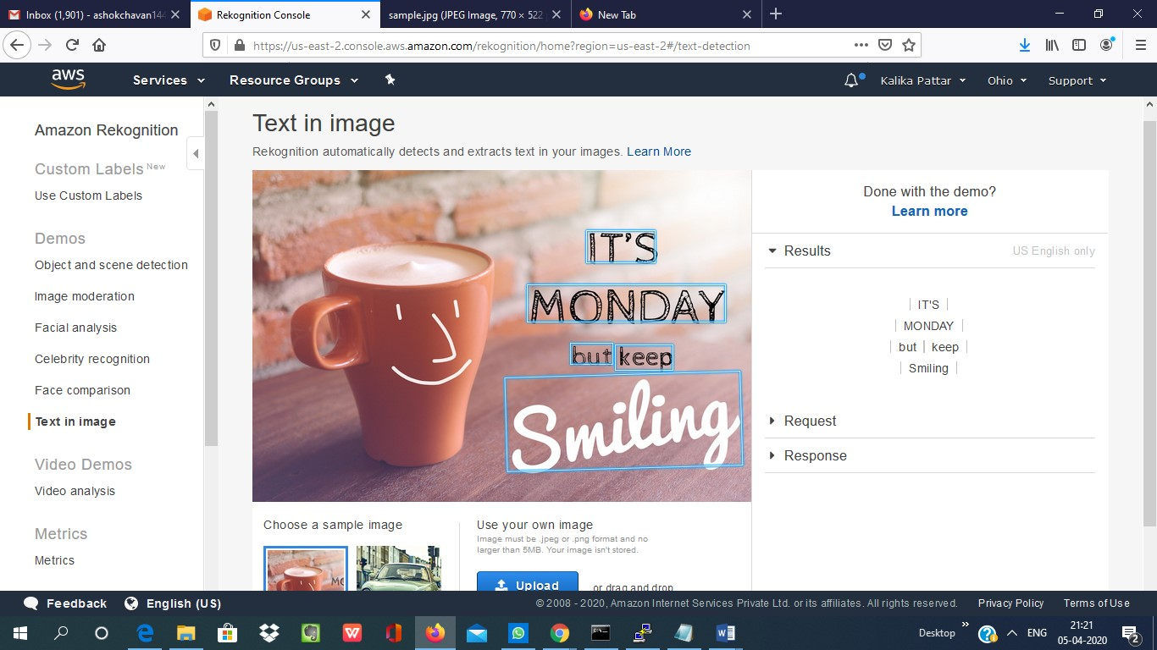

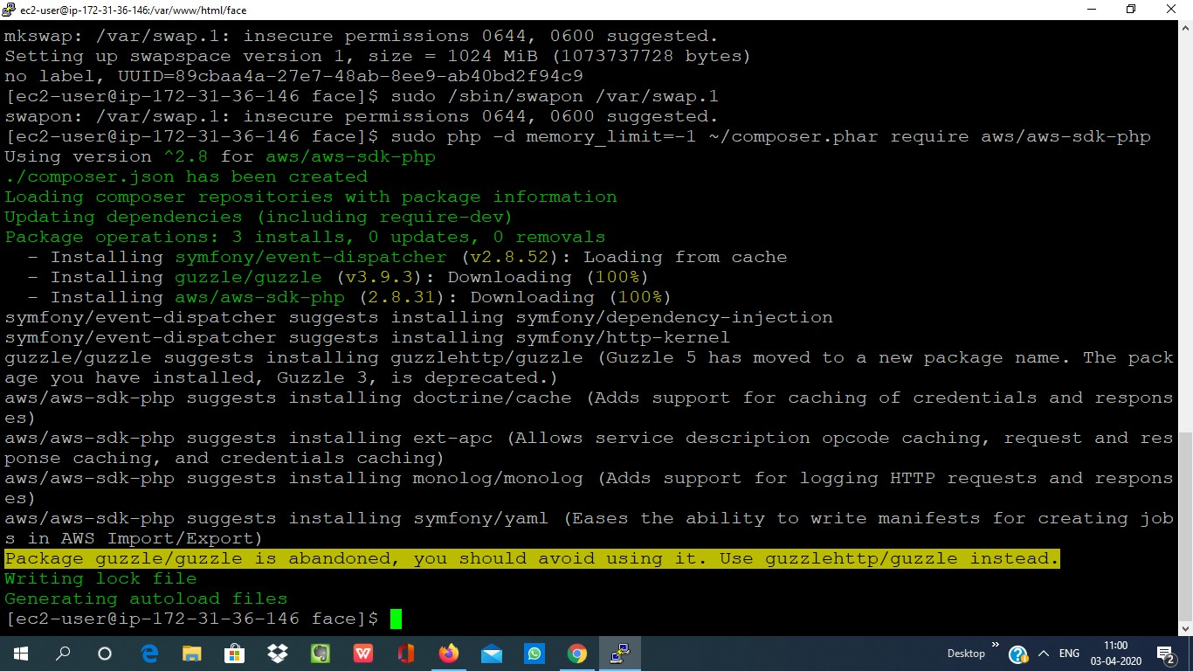EC2 AND S3

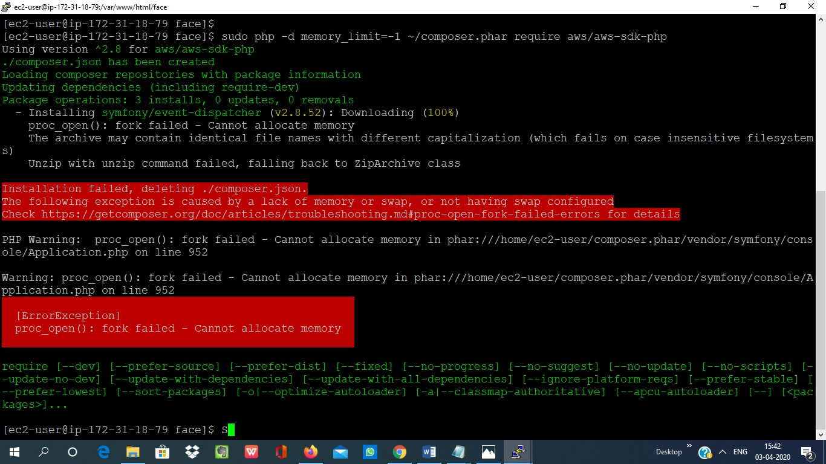**1. Installing aws-sdk**

**2. Installing php**

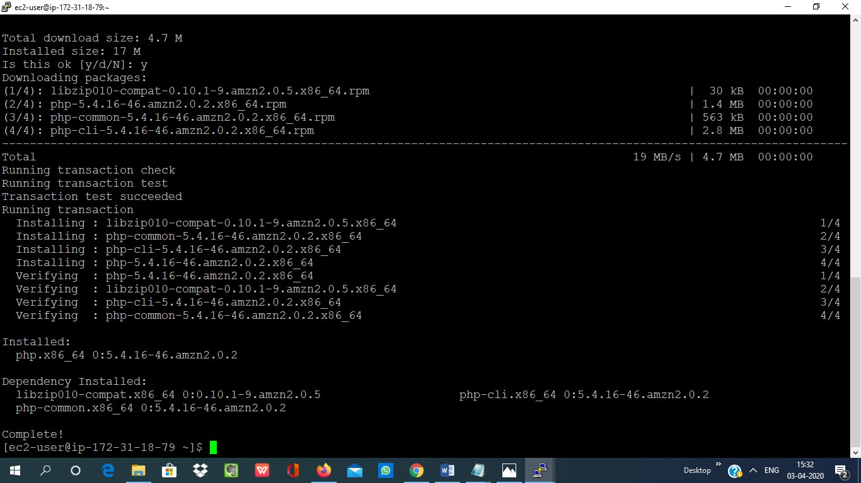

**3. Index.php file code**

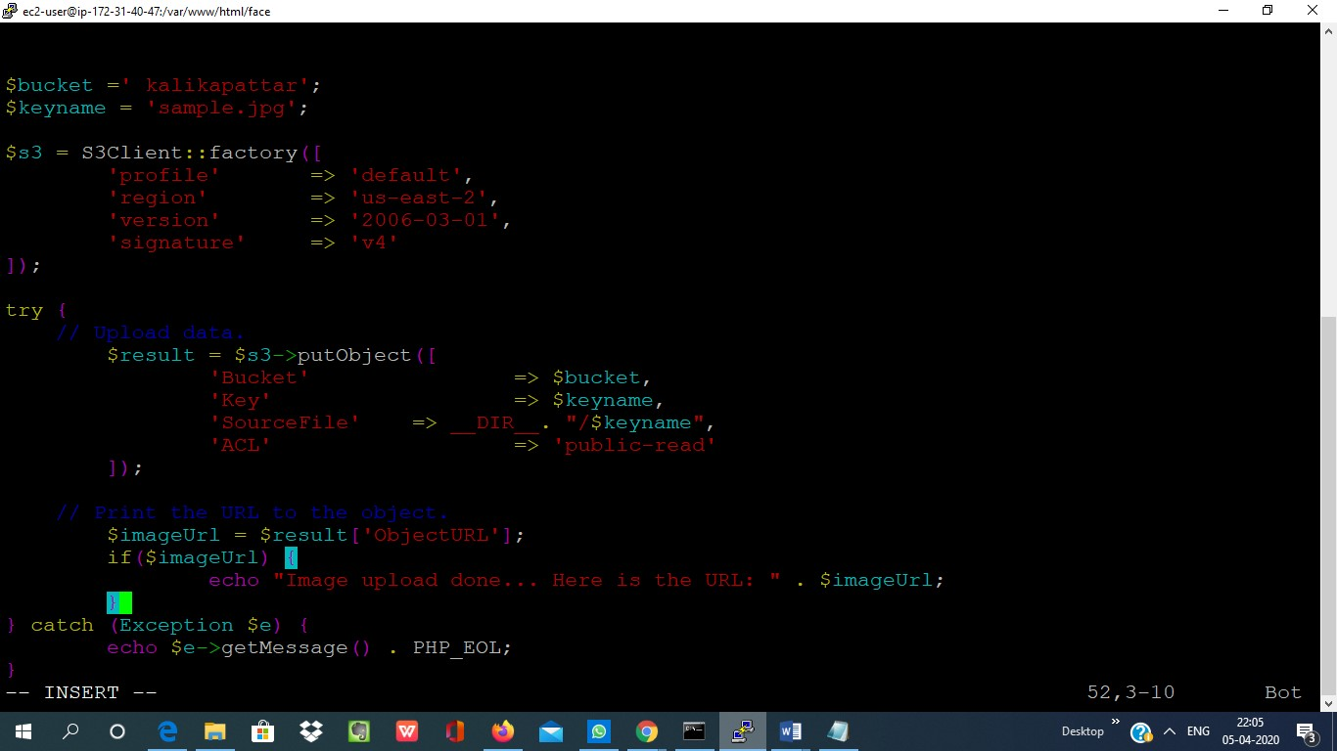

**4. UPOLOAD**

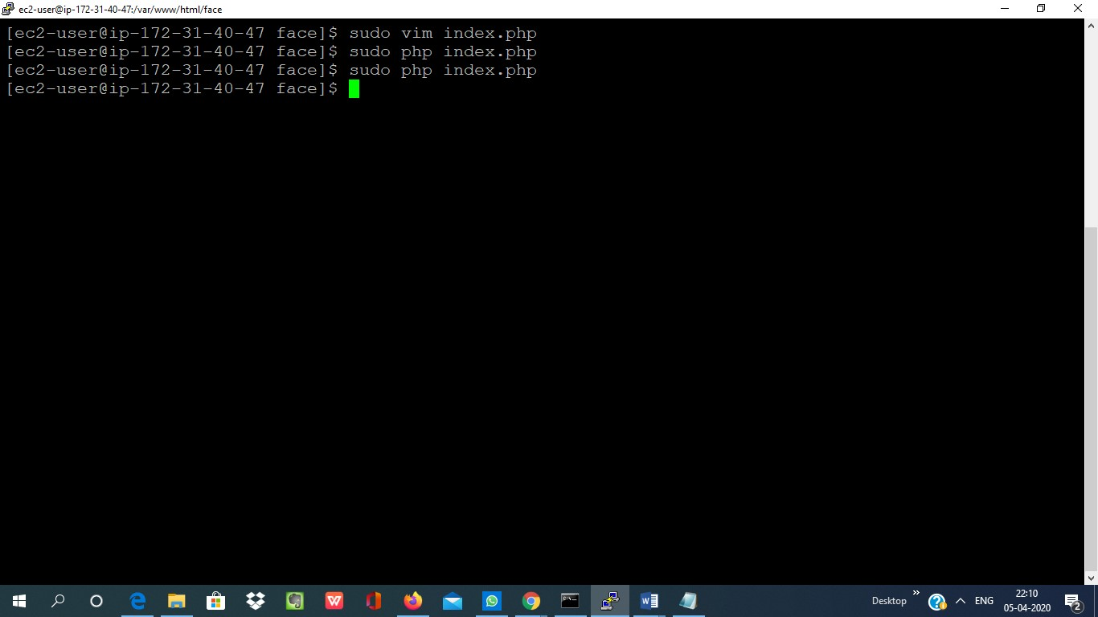

**EC2 AND REKOGNITION**

